40.4: a) The energy of the given photon is
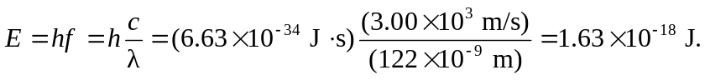
The energy levels of a particle in a box are given by Eq. 40.9
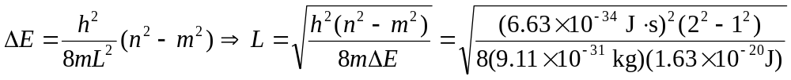
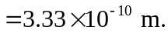
b) The ground state energy for an electron in a box of the calculated dimensions is (one-third of the original photon energy), which does not correspond to the 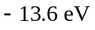 ground state energy of the hydrogen atom. Note that the energy levels for a particle in a box are proportional to 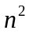, whereas the energy levels for the hydrogen atom are proportional to 

